CH Grocers

Trader Guide

This trader guide will control you through the features of the site and will likewise enable you to explore through our site effortlessly. Likewise, to ensure you don't have the problem of perusing long, exhausting and pointless aides, we've attempted our best to make this short, straightforward and justifiable. In the event that you have any further inquiries that the guide couldn't deliver please don't hesitate to get in touch with us on [chgrocers123@gmail.com](mailto:chgrocers123@gmail.com)

Trader Registration

Right going to our homepage you’ll notice a sign-up link on top right of the website. Click the Register as trader to register yourself.

After clicking a Register as trader button, a Trader registration fill up form will appear, fill up the form and click register. Trader will receive email from admin with a link to activate account click on the link to activate account.

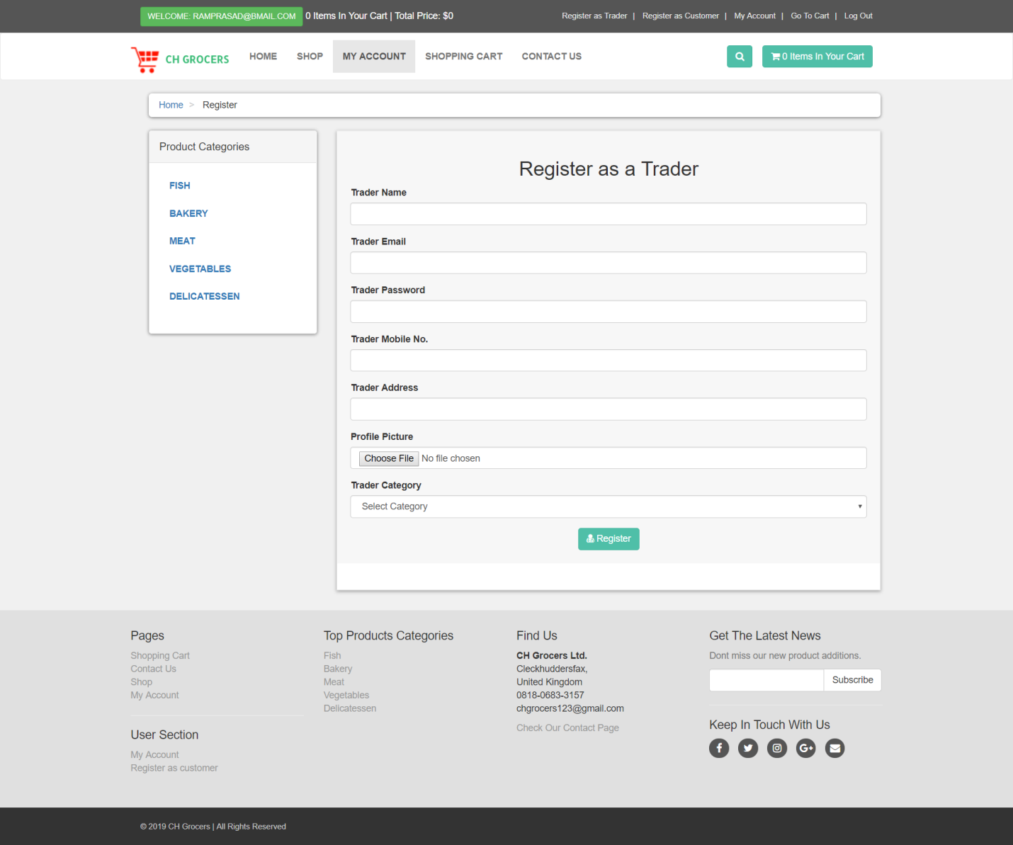

# Trader Login

You can log in as trader after you click on the link sent by admin to activate your account.

You can see a trader login option on the right hand site of the homepage click on it and a login page will appear enter your valid credentials to login and click on login.

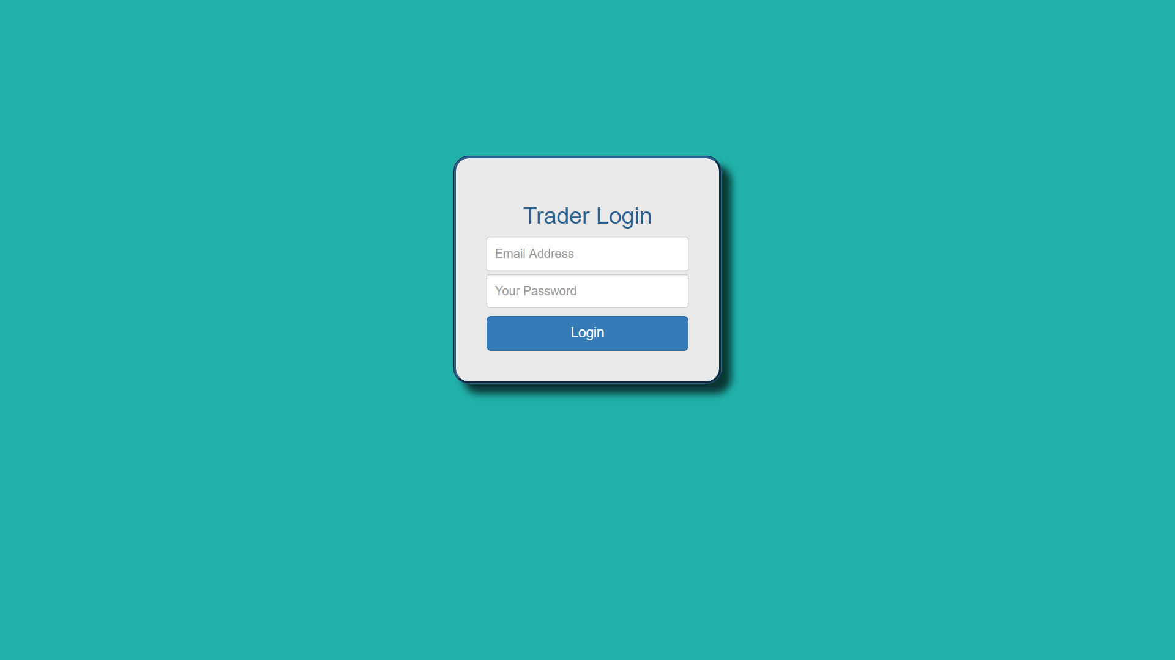

# Trader Products Dashboard

In the trader product dashboard you can insert,view,edit and delete your product and edit your account too.

# Insert products

Click on product drop down and click on insert product an insert product form will appear fill the details and click on insert product.

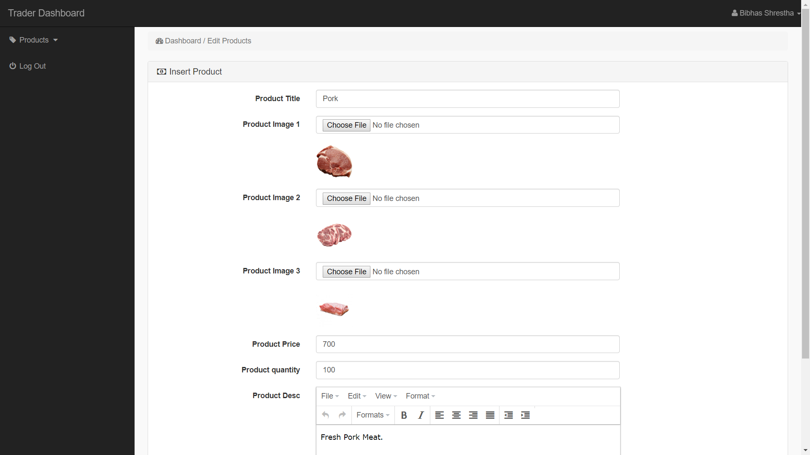

# View products

Click on product drop down click on view products here you can see the inserted products by you.

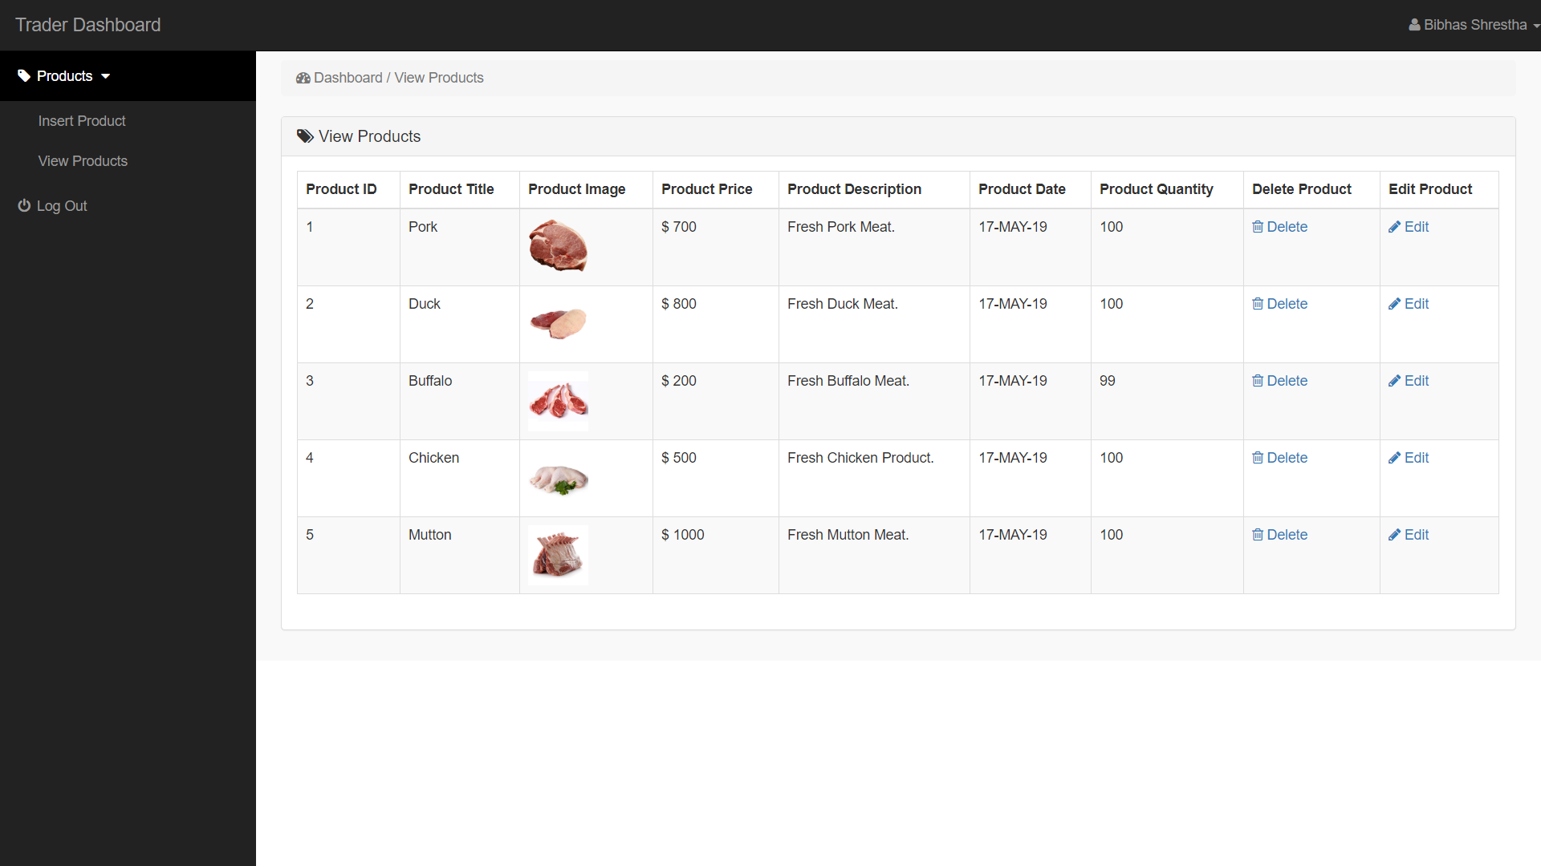

# Edit products

On the view products page you will see an edit button on the right hand side of the page click on edit an edit form will appear you can change the details and click on update product.



# Delete products

On the view products page you will see a delete button on the right hand side of the site. Click on it to delete your product.



# Edit Trader Profile

Click on trader name on the top right side of the trader dashboard and then click on profile, an edit user form will appear where you can again insert your details and click on update user.

